Week 2

Thanh Minh

Step 1:

Step 2:

Step 3: validate using W3C validator within the DreamWeaver

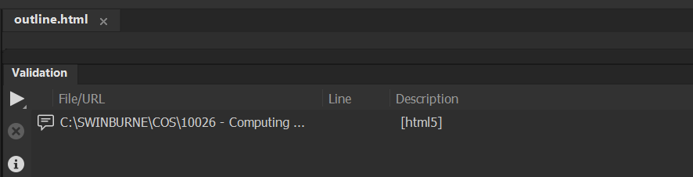

Step 4:

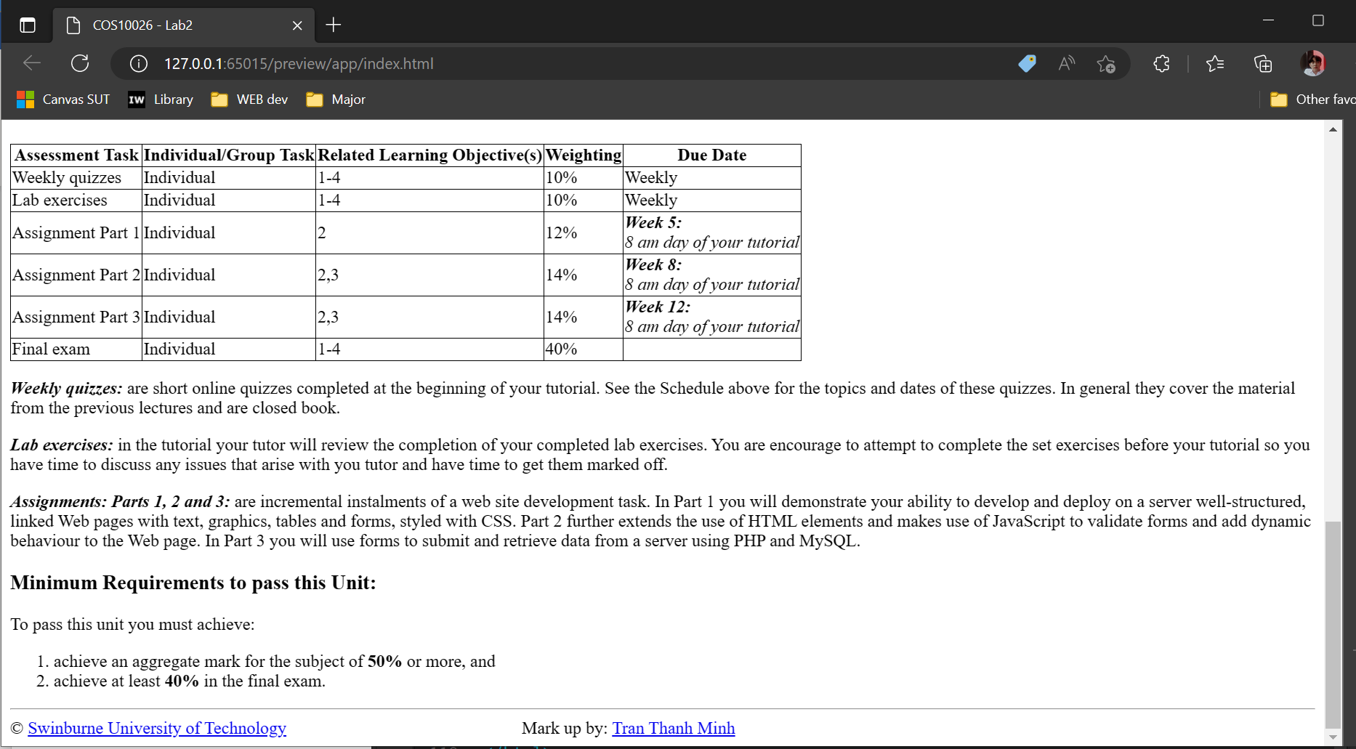

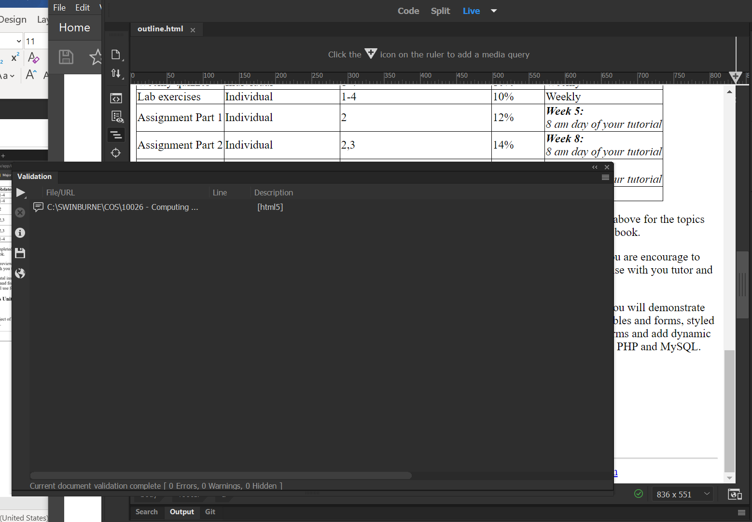

Step 5: Load file to server

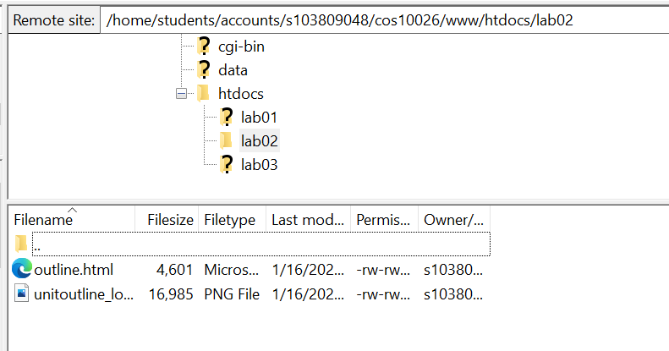

Step 6: Test the website

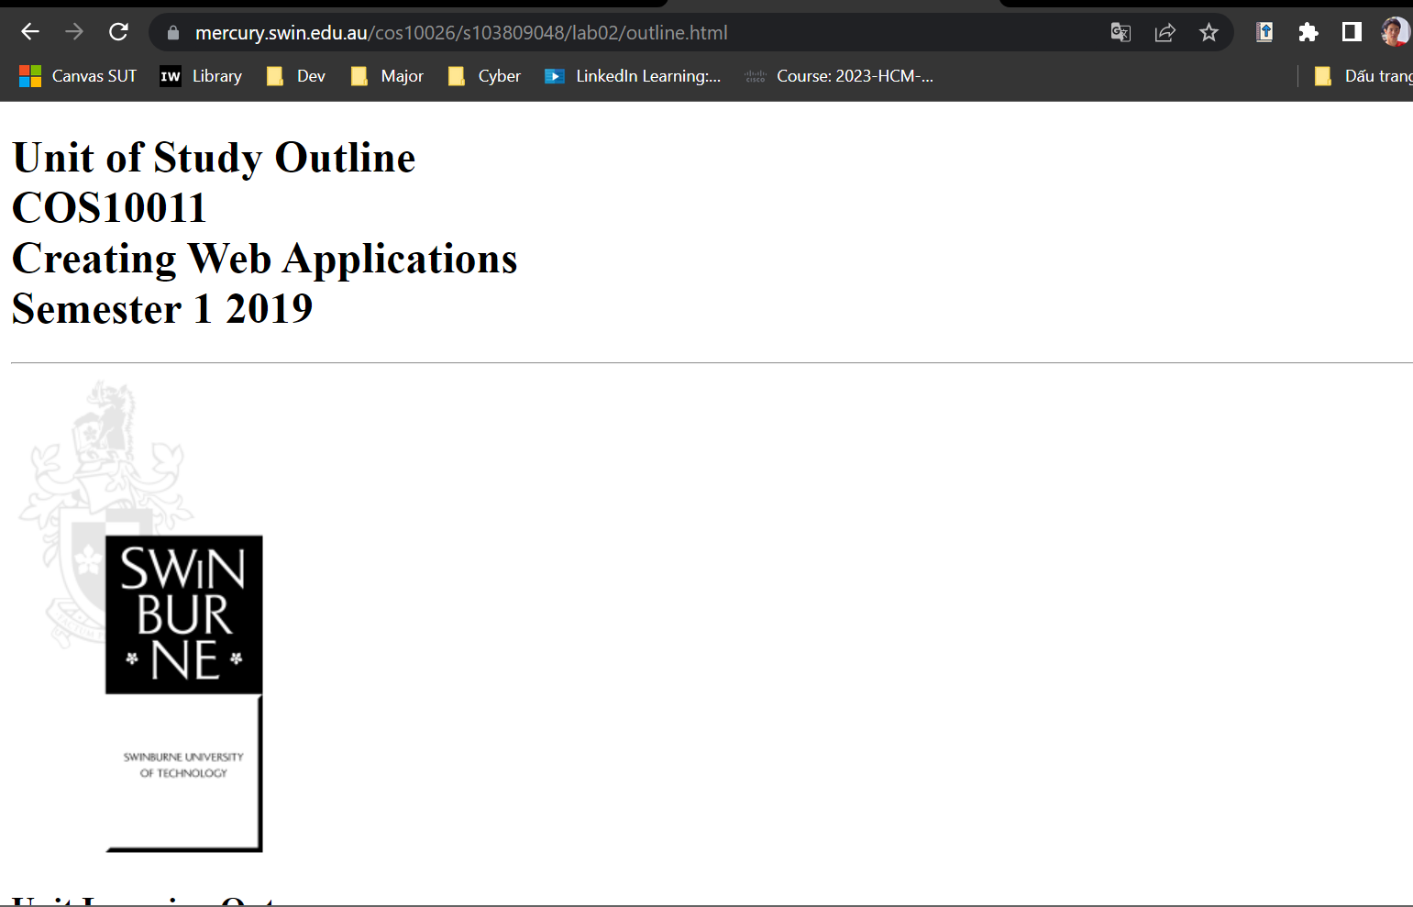

<https://mercury.swin.edu.au/cos10026/s103809048/lab02/outline.html>